Ideation Phase
Brainstorm & Idea Prioritization Template

Date | 19 October 2026
Team ID
Project Name | StaffSync
Maximum Marks | 4 Marks

Brainstorm & Idea Prioritization Template:
The team identifies recurring HR pain points and generates possible solutions before selecting ideas that offer clear user value and can be delivered within the project scope. The aim is to reduce repetitive work, improve transparency and make routine HR information easier to access—not to automate sensitive decisions without human review.
StaffSync ideas are grouped around employee records, attendance and leave management, role-based access, dashboards, notifications and an AI-assisted HR policy helper. Ideas are compared by user impact, implementation effort, feasibility and privacy risk so the first release remains practical and focused.
Reference: https://www.mural.co/templates/brainstorm-and-idea-prioritization
Step-1: Team Gathering, Collaboration and Select the Problem Statement

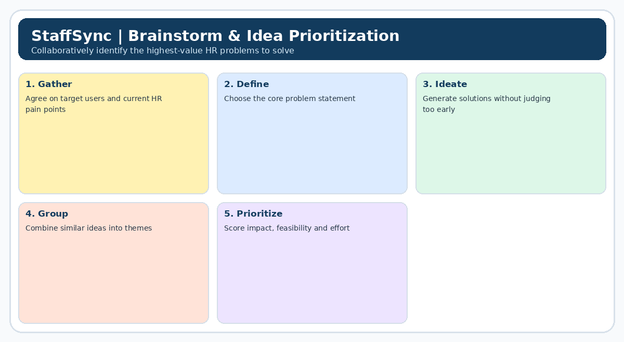

Step-2: Brainstorm, Idea Listing and Grouping
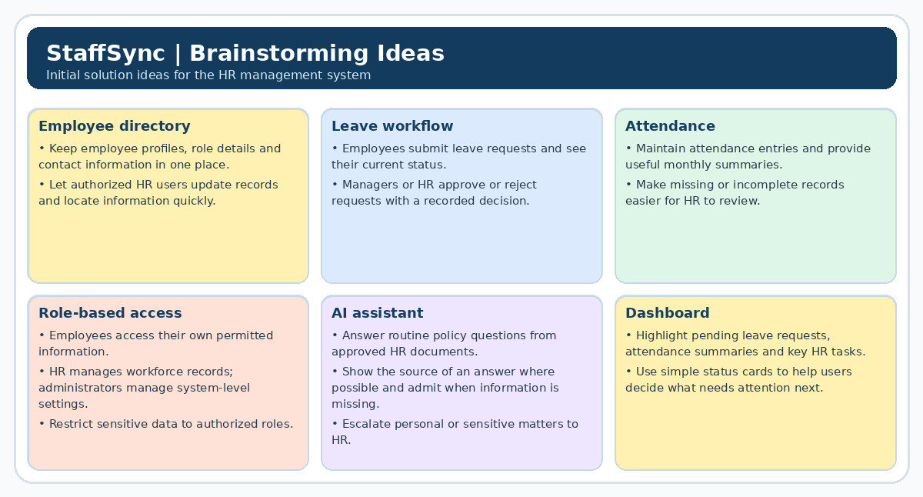
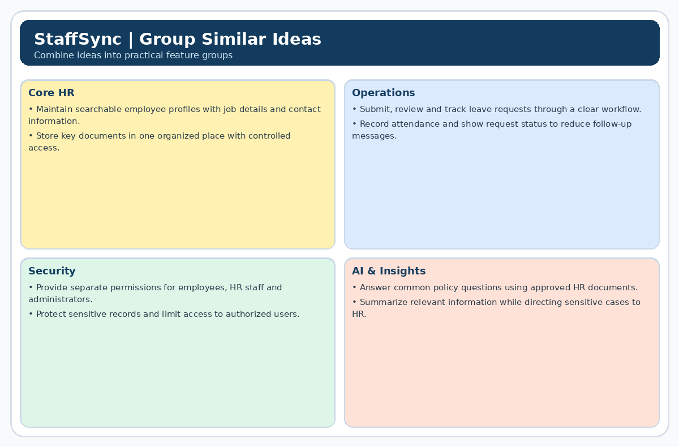

Step-3: Idea Prioritization
